20.15: a) 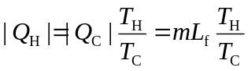
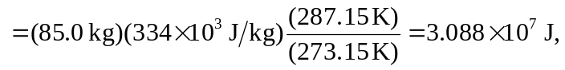
or
EMBED Equation.3 